 | Patented Product  专利产品 | Patten Number  专利号& 有效日 | Picture & Link  照片&链接
1 | A type of split-able high temperature tube furnace with wide range of working temperature  一种宽范围工作温度可开启式高温管式炉 | ZL-2011-2-0389859.8  2011-10-14 | 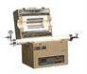
2 | A Type of Vacuum Tube Furnace  真空管式炉 | ZL-2011-2-0102249.4  2011-5-19 | 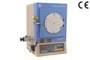
3 | A tilt-able Rotary Furnace  一种可倾斜式回转炉 | ZL-2011-2-0162234.8  2011-5-19 | 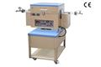
4 | A Rapid high temperature annealing furnace  一种快速高温退火炉 | ZL-2011-2-0077168.4  2011-3-22 | 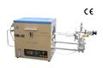
5 | A new type high temperature sintering tube furnace  一种新型高温烧结管式炉 | ZL-2011-2-0077178.8  2011-3-22 | 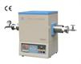
6 | A high temperature High Pressure Tube Furnace  一种高温高压管式炉 | ZL-2011-2-0077158  2011-3-22 | 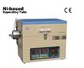
7 | Five Heated ZoneTube Furnace  五温区管式炉 | ZL-2011-2-0162224.4  2011-5-19 | 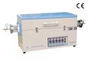
8 | Dual Tube Split-able Sintering Furnace  双管式开启烧结炉 | ZL-2011-2-0162232.9  2011-5-19 | 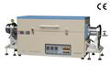
9 | A Combinable Plasma Enhanced CVD  可组合式等离子增强化学气相沉积装置 | ZL-2011-2-0355777.1  2011-9-21 | 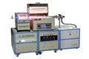
10 | A Vertical Split-able Tube Furnace  立式开启式管式炉 | ZL-2011-2-0162248.  2011-5-19 | 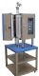
11 | A Doctor-Blade Coating Machine with Dryer  一种刮刀式烘干式涂膜机 | ZL-2011-2-0389876.1  2011-10-14 | 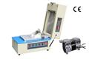
12 | Crimping Machine for Button Cell  扣式电池封装机 | ZL-2011-2-0462024.0  2011-11-18 | 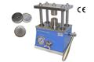
13 | Crimping Machine for Cylinder  圆柱状电池封装机 | ZL-2011-2-0463653.7  2011-11-18 | 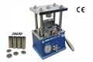
14 | Grooving Machine for Cylinder Cell  圆柱状电池滚槽机 | ZL-2011-2-0464651.8  2011-11-18 | 